ASSIGNMENT 6
Express.js Middleware
Student: Sasanka Sekhar Kundu
Backend Development • Express.js • Middleware

1. Objective
To implement and demonstrate three Express.js middleware concepts in a single application: router-level middleware, global request-logger middleware, and response-time middleware.

2. Assignment Structure
Sub-Question | Middleware | Scope | Routes
1 | routerLogger | Router-level | /api/students, /api/courses, /api/faculty
2 | logger | Global | /, /about, /contact
3 | responseTimeLogger | Global | /products, /users

3. Sub-Question 1 — Router-Level Middleware
A separate Express Router is created and the custom routerLogger middleware is attached using router.use(). The router is mounted at /api, so the middleware executes only for requests handled by this router.
Implemented routes:
- /api/students → Students List
- /api/courses → Courses List
- /api/faculty → Faculty List
The middleware records the HTTP method, the complete request URL, and the current date and time, then calls next() so the requested route can continue processing.

4. Sub-Question 2 — Request Logger Middleware
A custom global middleware named logger is registered with app.use(). It runs before the application routes and logs the HTTP method, request URL, and current date and time for incoming requests.
Implemented routes:
- / → Welcome to Home Page
- /about → About Us
- /contact → Contact Information

5. Sub-Question 3 — Response Time Middleware
The responseTimeLogger middleware records the start time with Date.now(). It listens for the response finish event and calculates the elapsed time in milliseconds before printing the HTTP method, request URL, and response time.
Implemented routes:
- /products → Product List
- /users → User List

6. Technologies and Dependencies
Technology: Node.js and Express.js
Dependency: express ^5.1.0
Entry point: server.js
Port used: 3000

7. Implementation Highlights
Concept | Implementation
Router-level middleware | router.use(routerLogger);
Router mounting | app.use("/api", router);
Global request logger | app.use(logger);
Response-time measurement | const startTime = Date.now();
Response completion | res.on("finish", () => { ... });
Middleware continuation | next();

8. Practical Execution Evidence
The following screenshots document successful browser responses for all required routes.
Sub-Question 1: /api/students — Students List


Sub-Question 1: /api/courses — Courses List


Sub-Question 1: /api/faculty — Faculty List


Sub-Question 2: / — Welcome to Home Page


Sub-Question 2: /about — About Us


Sub-Question 2: /contact — Contact Information
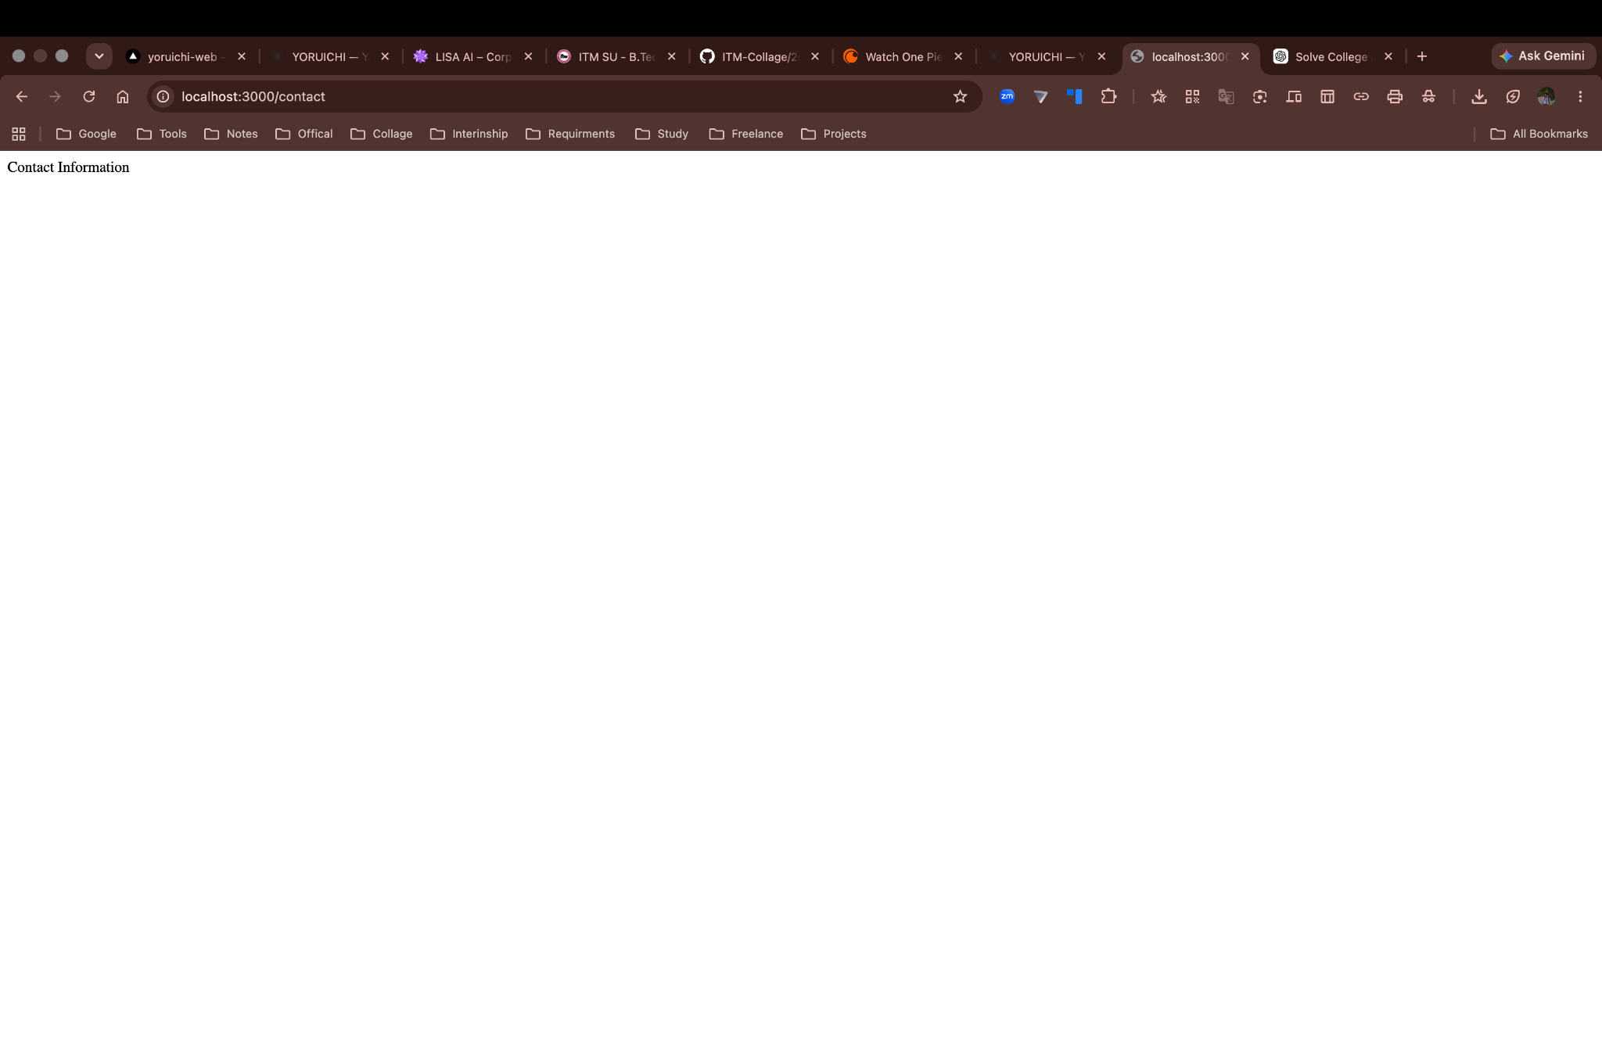

Sub-Question 3: /products — Product List
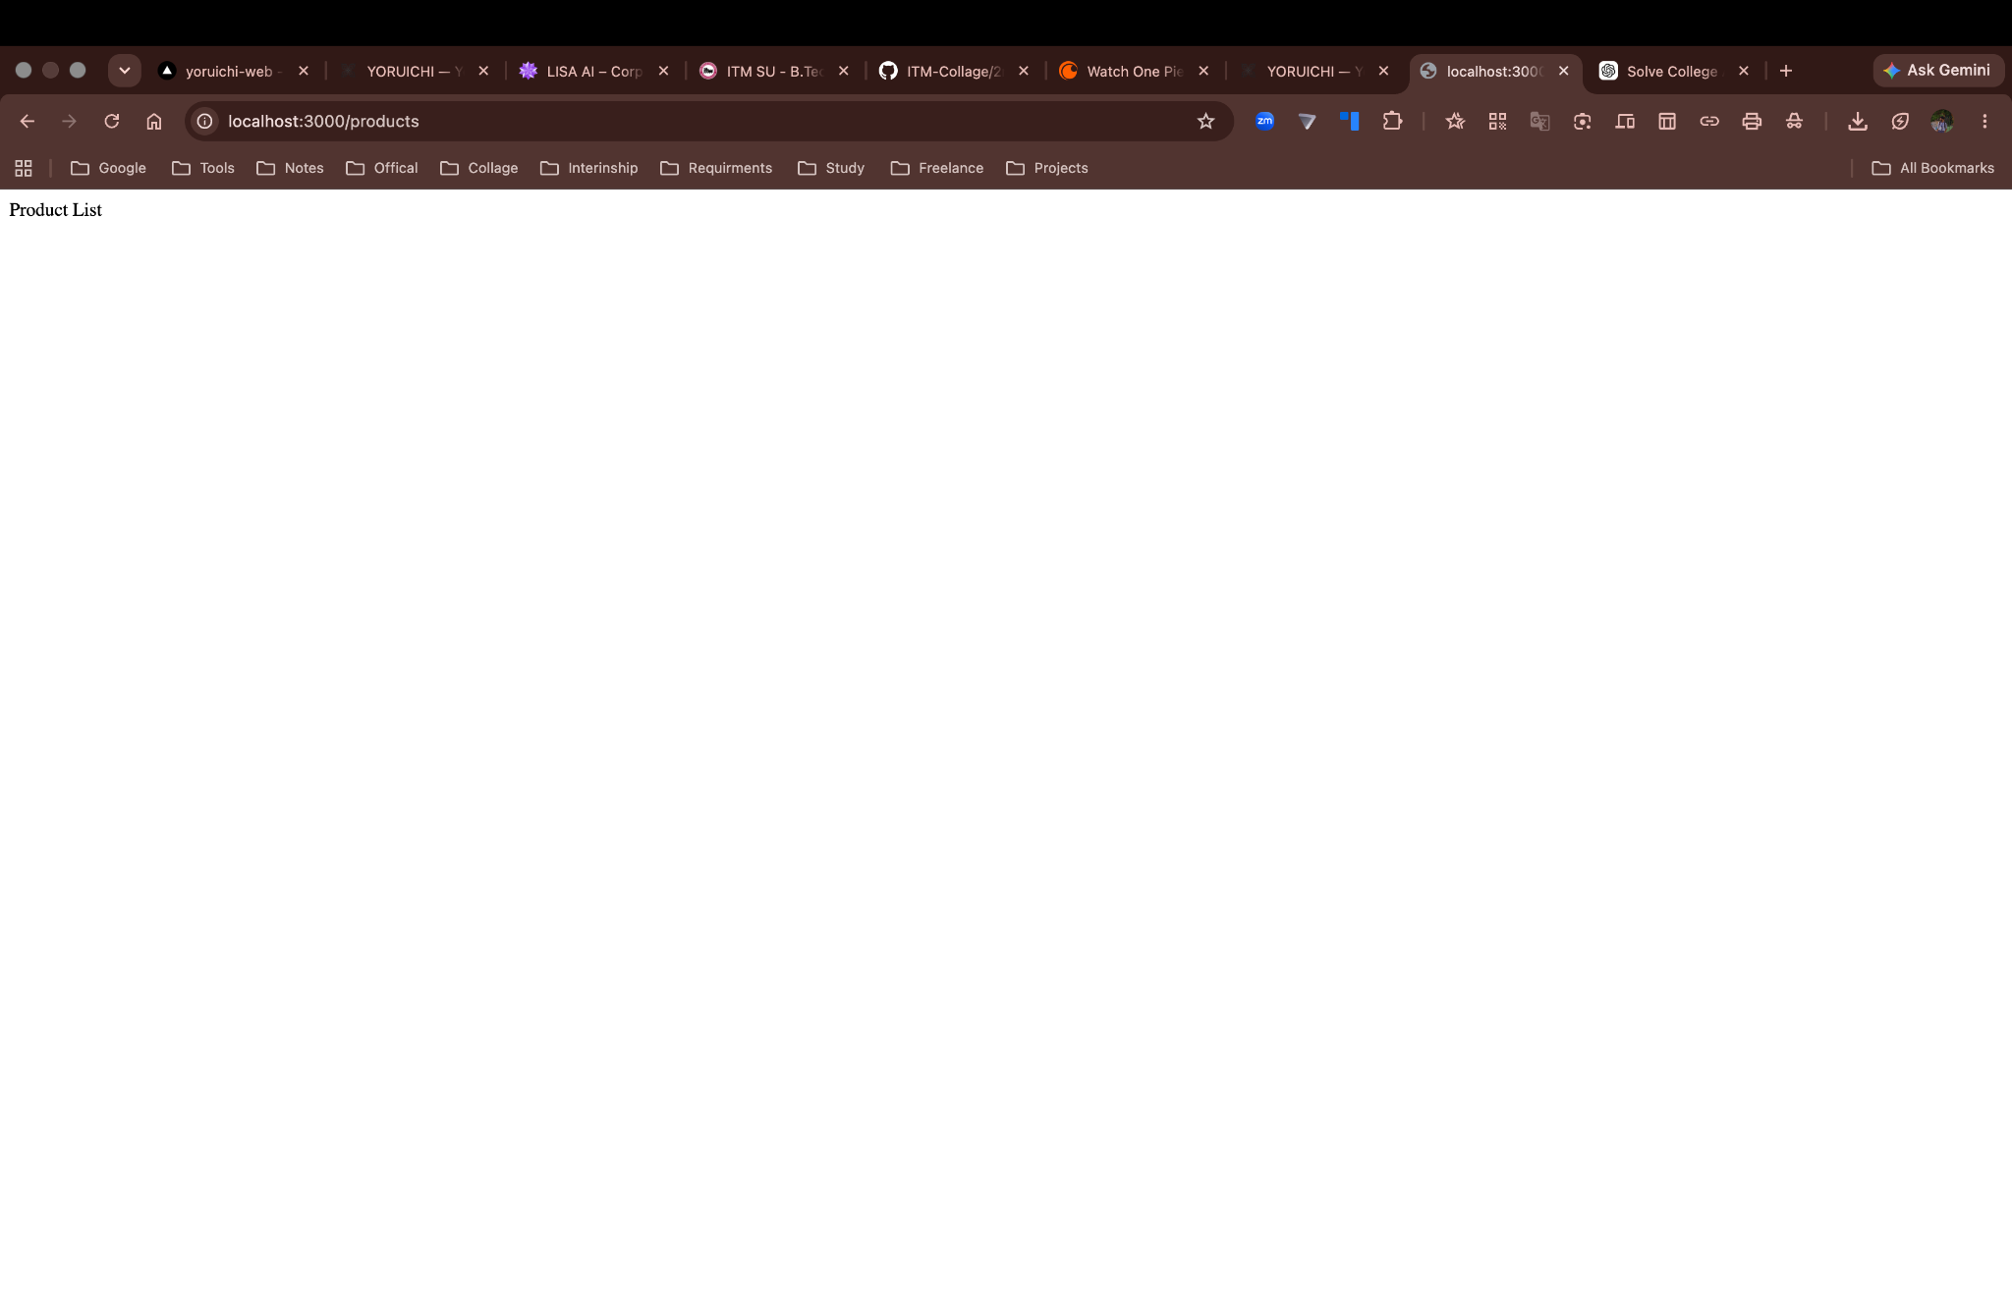

Sub-Question 3: /users — User List


9. Result
The Express.js application was executed successfully on localhost:3000. The required router-level routes, global request-logger routes, and response-time routes returned their expected responses in the browser. The screenshots provide practical evidence of the route execution.

10. Conclusion
This assignment demonstrates the use of Express.js middleware at different levels. The first part shows router-specific middleware, the second demonstrates global middleware using app.use(), and the third measures request processing time using Date.now() and the response finish event. The application uses next() to continue the middleware and routing lifecycle.

